Online shopping system- web application
User login test cases

Module Name: Online shopping system test cases(Web)
Test case ID: TC004
Platform: Web application (Responsive)
Login Method: Email and password
Registration Method: Name, Email, password, Date of birth, Address , Mobile number.

Home page

Scenario ID: 1
Scenario: Registration- valid data
Test steps:
- Enter valid Email :patelvidhi223@gmail.com
- Enter valid password:Vidhi01223
- Click on sign up
- Enter Name: vidhi
- Enter date of birth: 22nd march 2007
- First name: vidhi
- Last name: patel
- Address 1: Near damru circle,
- Address 2: chanakyapuri, gatlodia
- Country:India
- State: gujarat
- City: Ahemdabad
- Zipcode: 380061
- Mobile number: 1234567890
- Click on create Account
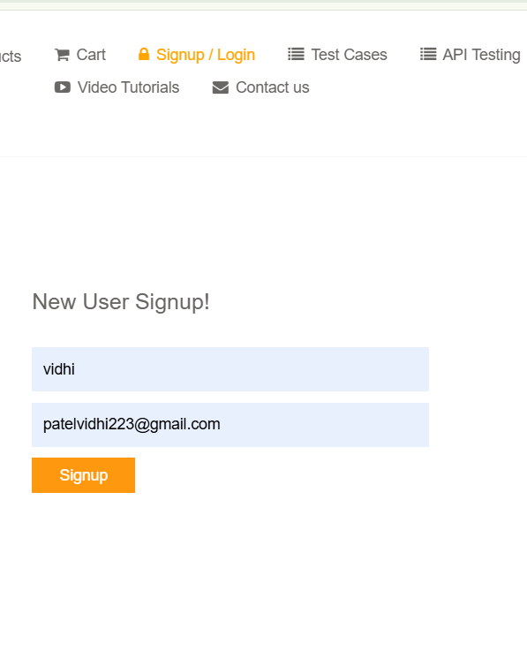
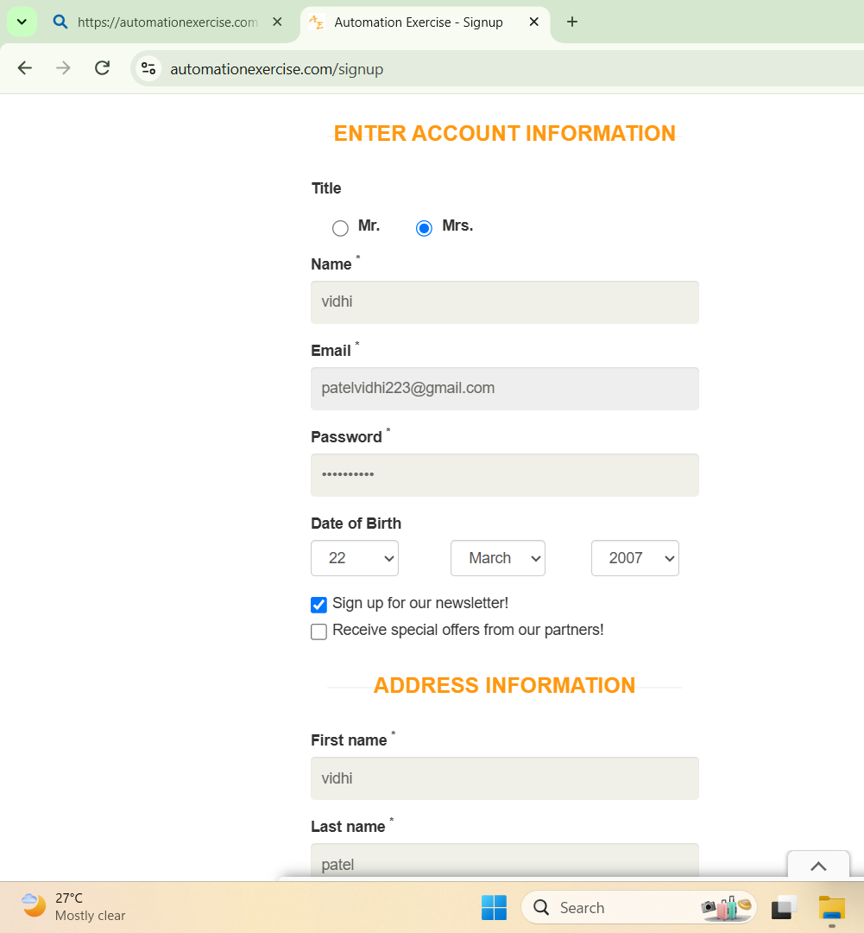
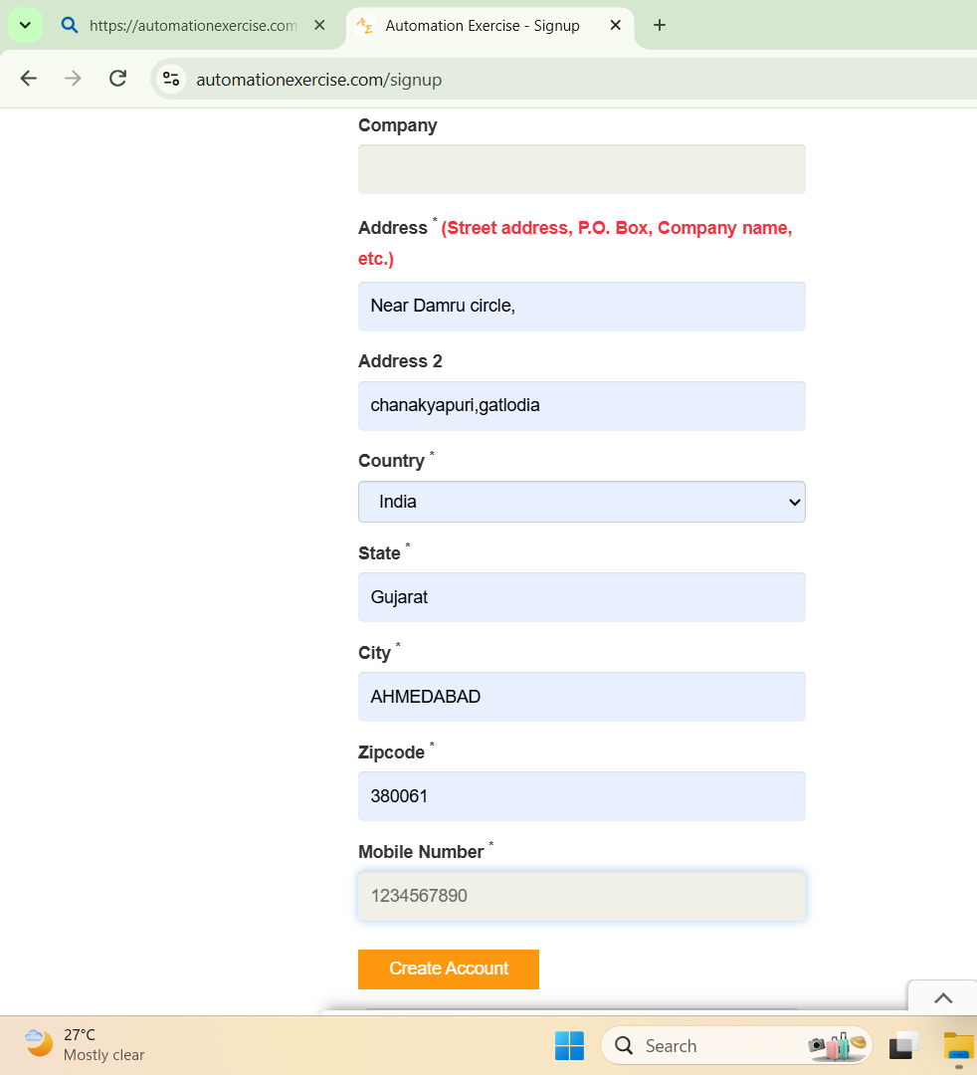

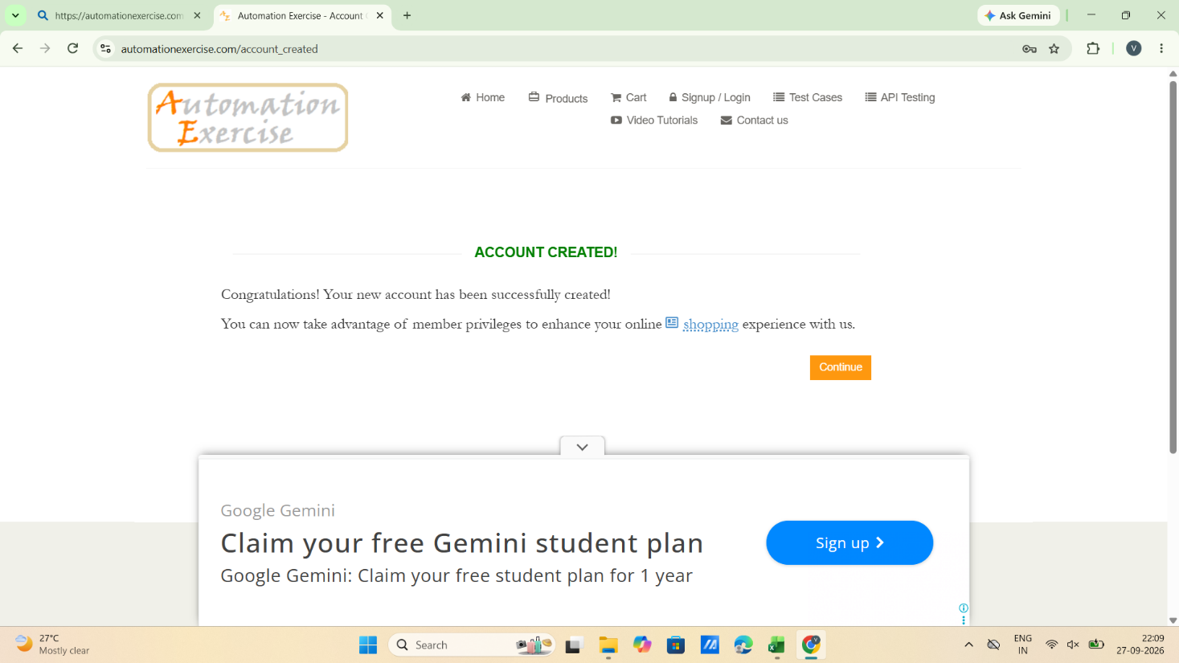

Scenario ID: 2
Scenario: Registration- Duplicate Email(existing email)
Test steps:
- Enter valid Email :patelvidhi223@gmail.com
- Enter valid password:Vidhi01223
- Click on sign up

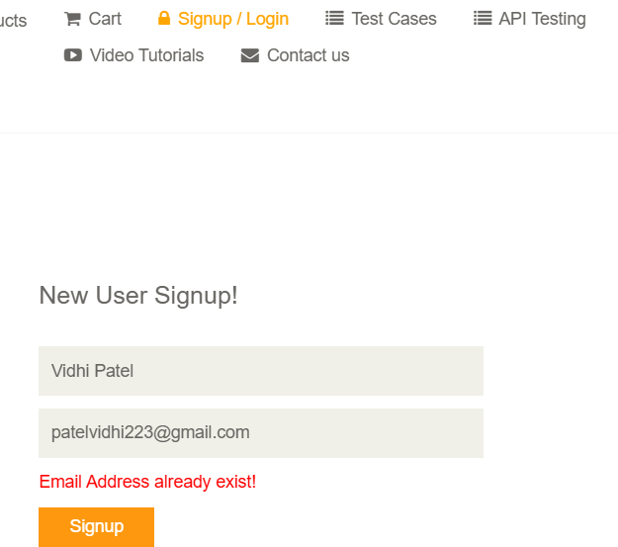

Scenario ID: 3
Scenario: valid login
Test steps:
- Enter valid Email :patelvidhi223@gmail.com
- Enter valid password:Vidhi01223
- Click on login
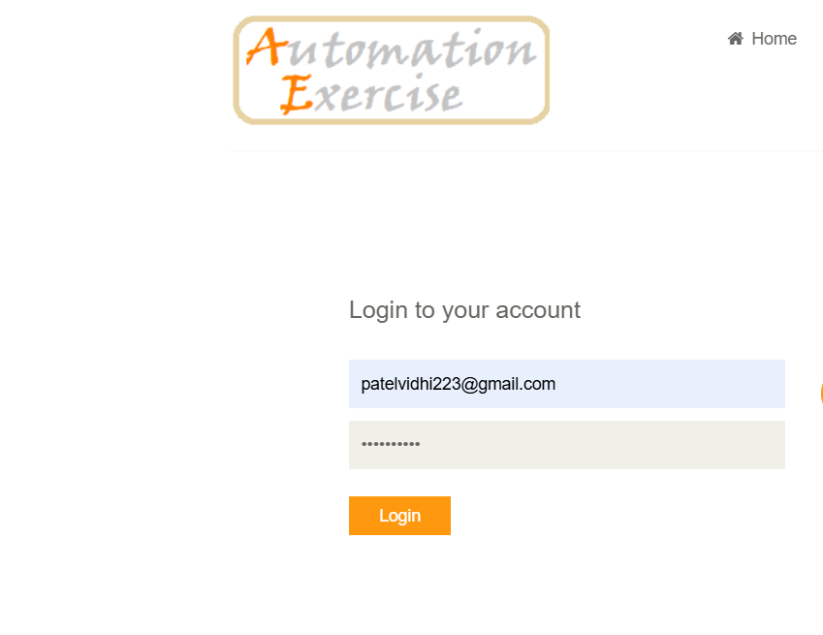
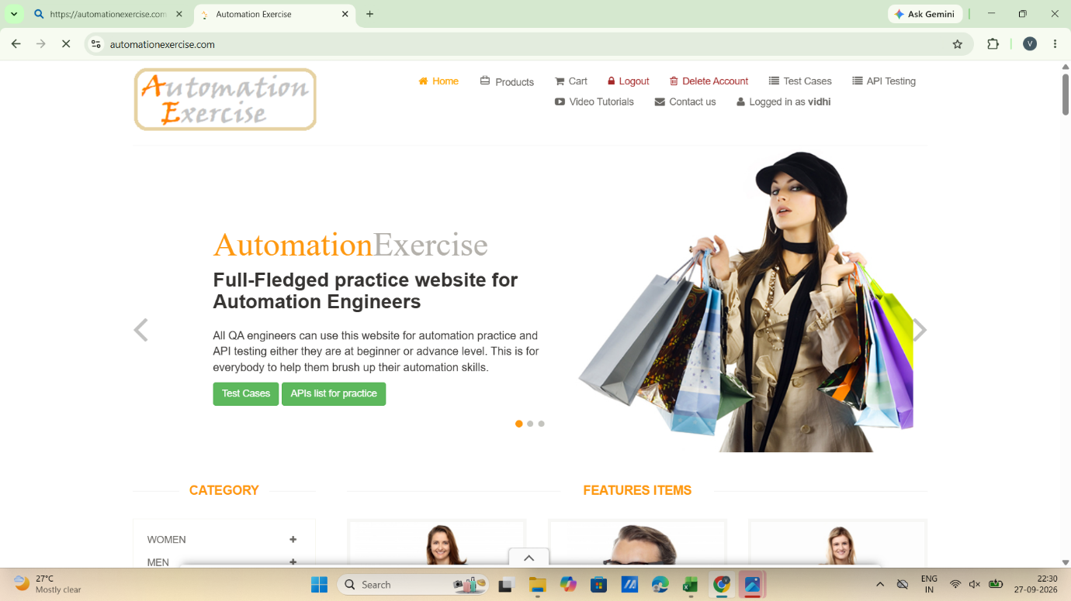

Scenario ID: 4
Scenario: login with invalid Email
Test steps:
- Enter valid Email :patelvidhi87@gmail.com
- Enter valid password:Vidhi01223
- Click on login

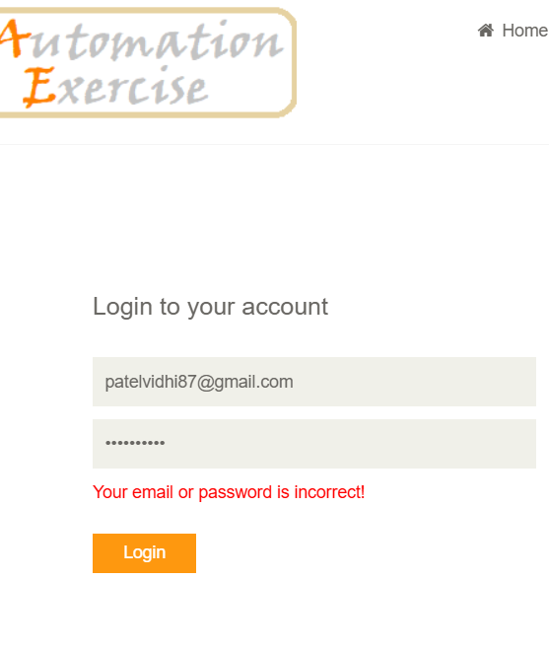

Scenario ID: 5
Scenario: login with invalid password
Test steps:
- Enter valid Email :patelvidhi223@gmail.com
- Enter valid password:tilak01223
- Click on login

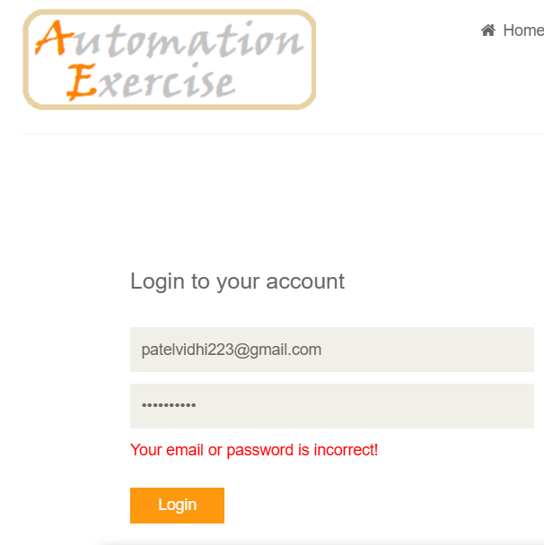

Scenario ID: 6
Scenario: leave blank fields
Test steps:
- Leave blank Email field
- Leave password field blank
- Click on login

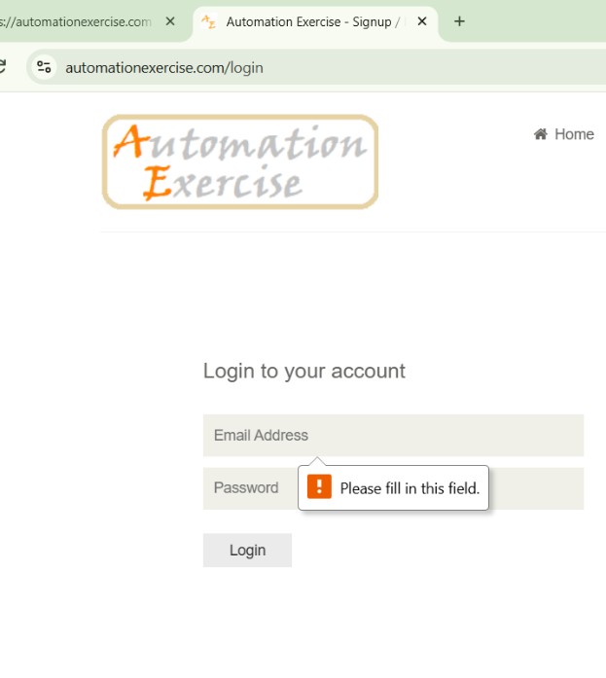

Scenario ID: 7
Scenario: Add products to cart
Test steps:
- Select product
- Click add to cart
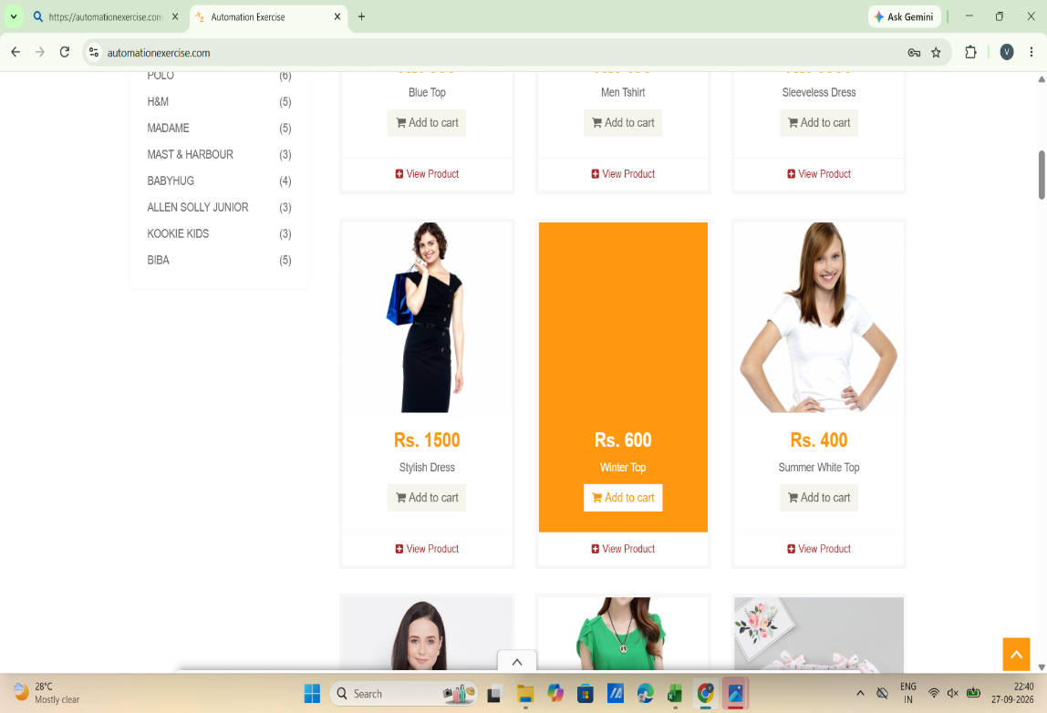

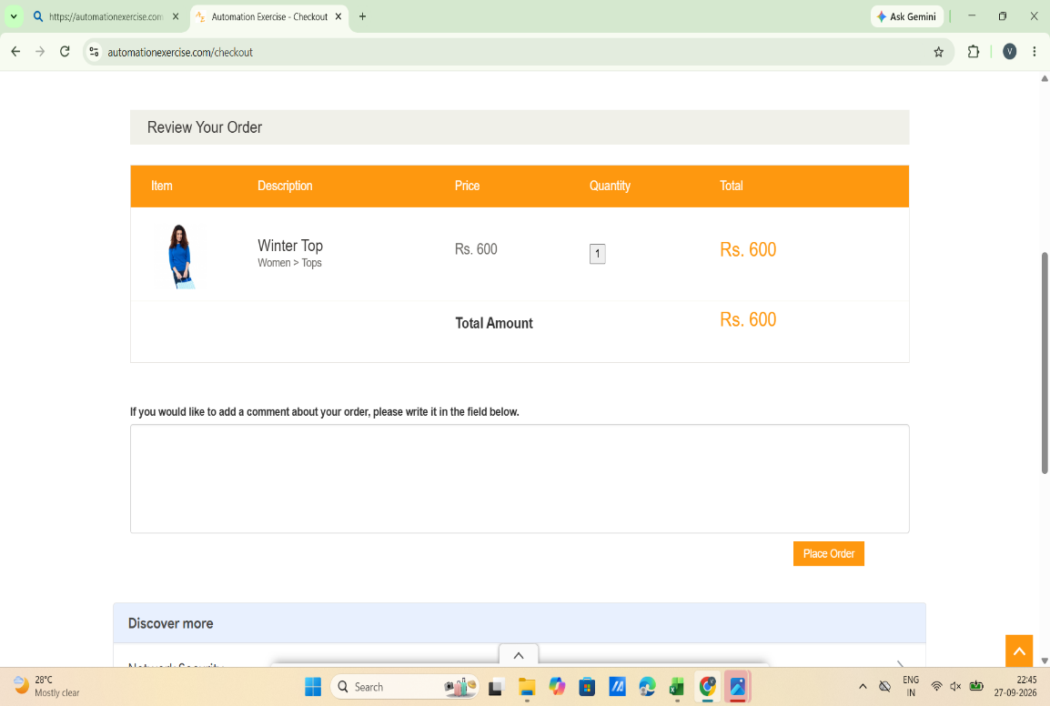

Scenario ID: 8
Scenario: checkout—valid card details
Test steps:
- Enter name on card: vidhi patel;
- Enter card number:411111111111
- Enter CVC number:993
- Enter expiration: MM-1, YEAR:2000
- Click pay and confirm
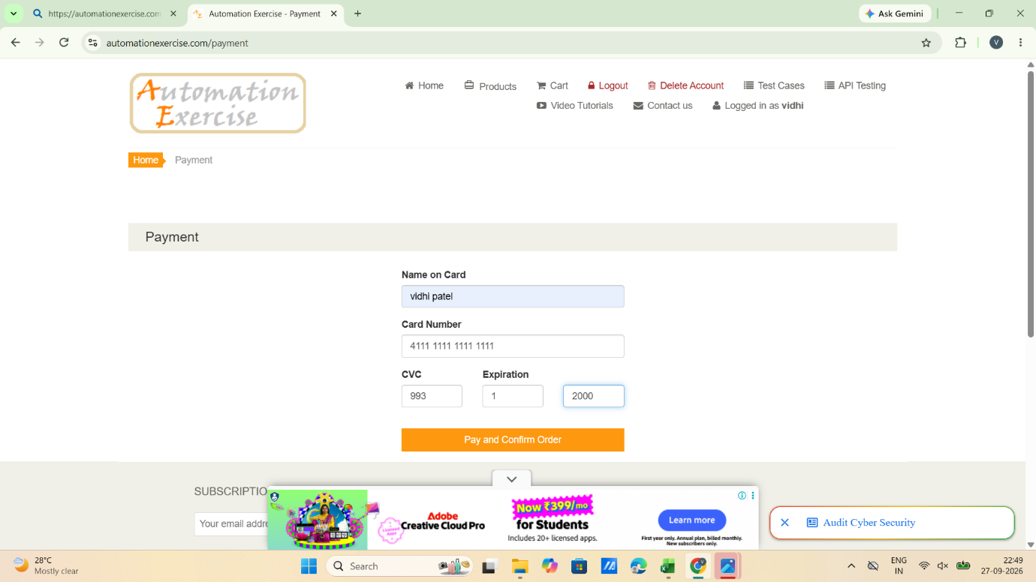

Scenario ID: 9
Scenario: checkout with blank card details
Test steps:
- Enter name on card: -
- Enter card number:-
- Enter CVC number:-
- Enter expiration: MM:- , YEAR:-
- Click pay and confirmd number

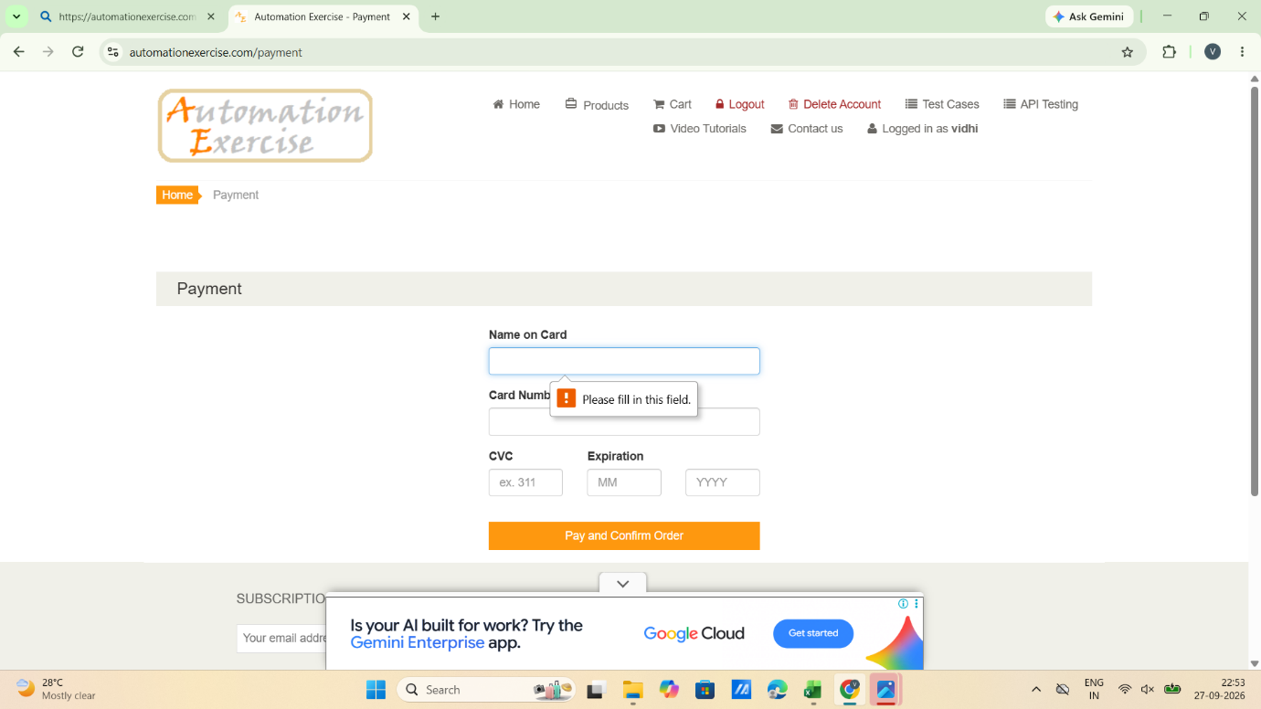

Scenario ID: 10
Scenario: logout functionality
Test steps:
- Enter valid Email :patelvidhi223@gmail.com
- Enter valid password:Vidhi01223
- Click on login
- Click on logout
